CSE161 Quiz 2 Section 2 06/10/2010

ID __________________ Name in CAPITAL ______________________________________________

Draw the flowchart of a program that calculates the sum of first 9 terms of the following series 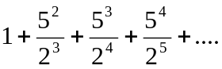

Hint: If you multiply, power increases by one.

